Solution of the Linearized Equations of Motion
ASEN 5070
4/22/02

G. H. Born

Introduction

The equations of motion for a satellite are given by:

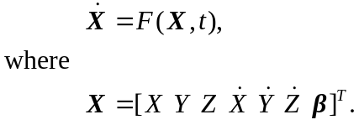 (1)

X is the state vector containing six position and velocity elements and β, an m vector, represents all constant parameters such as gravity and drag coefficients that are to be solved for. Hence, X is a vector of dimension n=m+6.

Equation (1) can be linearized by expanding about a reference state vector denoted by X*, i.e.

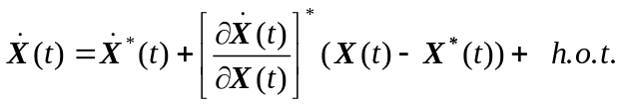 (2)

The * indicates that the quantity is evaluated on the reference state. By ignoring higher order terms (h.o.t.) and defining

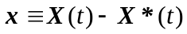, (3)

we can write Eq. (2) as

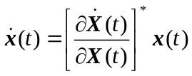. (4)

Define

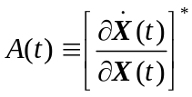,

then

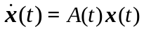. (5)

Equation (5) is a linear system of first order differential equations with A being an n x n time varying matrix evaluated on the known reference state X*. Note that
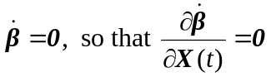.

Because Eq. (4) is linear and of the form , the solution can be written as

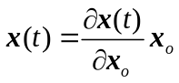.
It is also true that
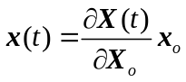. (6)

This follows from the fact that the reference state does not vary in this operation, i. e.,

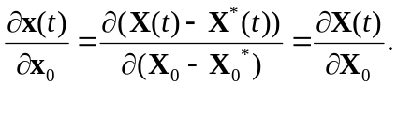
It is easily shown that Eq. (6) satisfies Eq. (5). Differentiating Eq. (6) yields (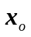 is a constant vector)

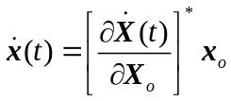. (7)

Equating Eq. (7) and Eq. (4) and using Eq. (6) yields

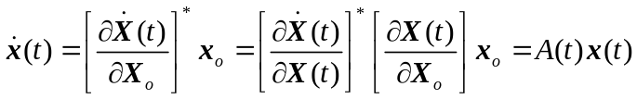. (8)

Substituting Eq. (6) and (7) into Eq. (5) yields

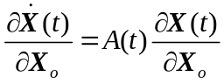. (9)

Define the state transition matrix to be

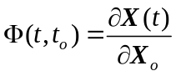. (10)

The differential equation for the state transition matrix is given by Eq. (9)

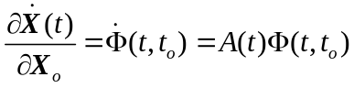, (11)
with initial conditions

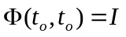.

Consequently, Eq. (6) may be written as

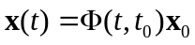. (12)

The State Transition Matrix

Insight into the nxn state transition matrix can be obtained as follows. Let

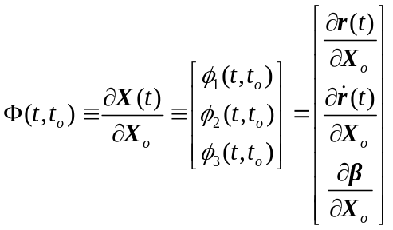. (13)

Note that 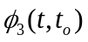is an m x n matrix of constants partitioned into an mx6 matrix of zeros on the left and an mxm identity matrix on the right, where m is the dimension of β and X is of dimension n. Because of this, it is only necessary to solve the upper 6xn portion of Eq. (11).

Equation (11) also can be written in terms of a second order differential equation. This can be shown by differentiating Eq. (13)

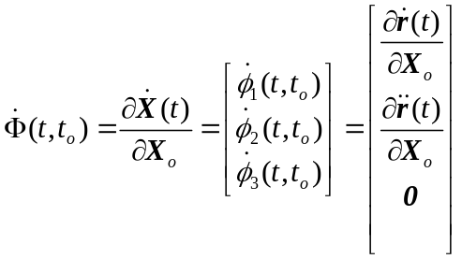
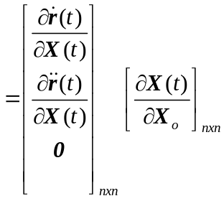. (14)

In the above equations 0 represents an mxn null matrix. Notice from the first of Eqs. (14) that

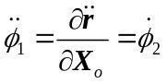. (15)

Hence, we could solve this second order system of differential equations to obtain 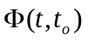, i.e.,

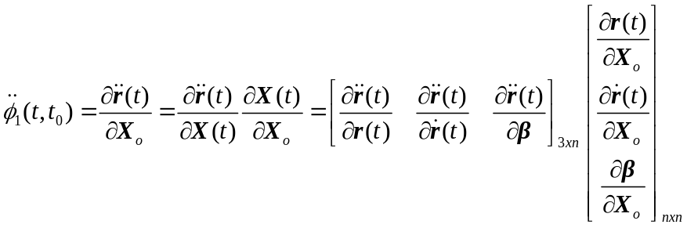 (16)

or,

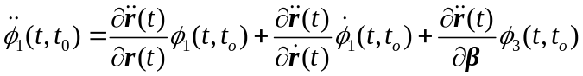. (17)
With initial conditions

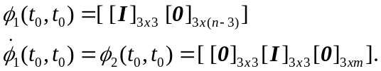

We could solve Eq. (17), a 3 x n system of second order differential equations, instead of the 6 x n first order system given by Eq. (11). Recall that the partial derivatives are evaluated on the reference state and that the solution of the m x n system represented by 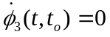 is trivial, i.e.,

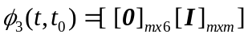.
In solving Eq. (17) we could write it as a system of n x n first order equations, i.e.,

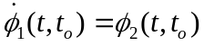

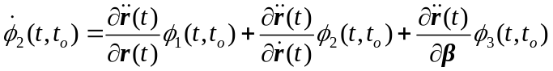 (18)

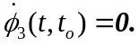

It is easily shown that Eq. (18) is identical to Eq. (11), i. e.,

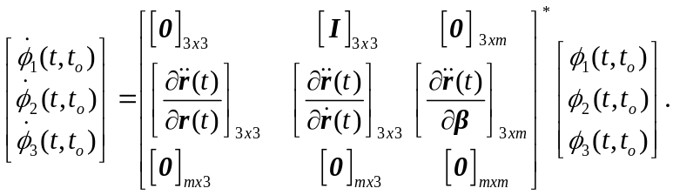
Or,
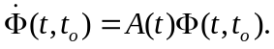

A differential equation of any order (order of highest-ordered derivative) is said to be linear when it is of the first degree in the dependent variable and its derivatives and their products e. g.,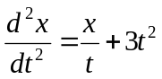is a second order equation of first degree (hence linear), while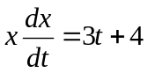is second degree and nonlinear.

